| **National University of Computer and Emerging Sciences, Lahore Campus** | | | | |
| --- | --- | --- | --- | --- |
| C:\Users\saif\AppData\Local\Microsoft\Windows\Temporary Internet Files\Content.Word\final design.jpg | **Course:** | **Software Engineering** | **Course Code:** | **CS-303** |
| **Program:** | **BS(Computer Science)** | **Semester:** | **Fall 2017** |
| **Duration:** | **180 Minutes** | **Total Marks:** | **80** |
| **Paper Date:** | **14-Dec-17** | **Weight** | **40%** |
| **Section:** | **D & E** | **Page(s):** | **9** |
| **Exam:** | **Final** | **Reg. No.** |  |
| **Instruction/Notes:** | 1. State your assumptions clearly 2. Answer in the space provided 3. Answer all questions in context of class discussions, handouts and the text books. | | | |

**Q1 10+5+5= 20 Marks**

One Parking is about to launch the first version of a parking garage/lot automation project, **Reserve ‐ Your Spot**. The parking garage currently operates without any computerized system. The management has concerns about inefficiencies of sub‐optimal usage of parking space. In addition, there are frequent instances of congestion inside the garage, caused by drivers searching for vacant spots. Currently, management monitors the available locations in the garage by having employees walk around the decks to inspect if the individual spots are occupied or vacant.

The purpose of Reserve ‐Your ‐Spot is to track and manage availability of parking slots in the garage and allow registered customers to find and reserve available parking places. The reservation can be made for single day as well as multiple days. The payment of reservation shall be online or on-site through credit card only. The users can view the parking garage visually on the mobile screen. The reserved spots will be shown red however the vacant spots will be shown green. The reservation can be made either through the visual layout of the garage or user can request for a reservation and the system itself would reserve a location and notify the user through message or e-mail.

**To do:**

1. Specify at least 10 functional requirements of Reserve your spot system. You may specify requirements that should be in the system and are not given in the problem statement
2. Specify at least 5 non-functional requirements of Reserve your spot system. You may specify requirements that should be in the system and are not given in the problem statement
3. Since it is a new system to be built and you can easily assess from the statement if the system is large, medium, or small. Given the information about the Reserve your spot system, which process model (s) is/are the most appropriate to develop this system? Justify your answer.

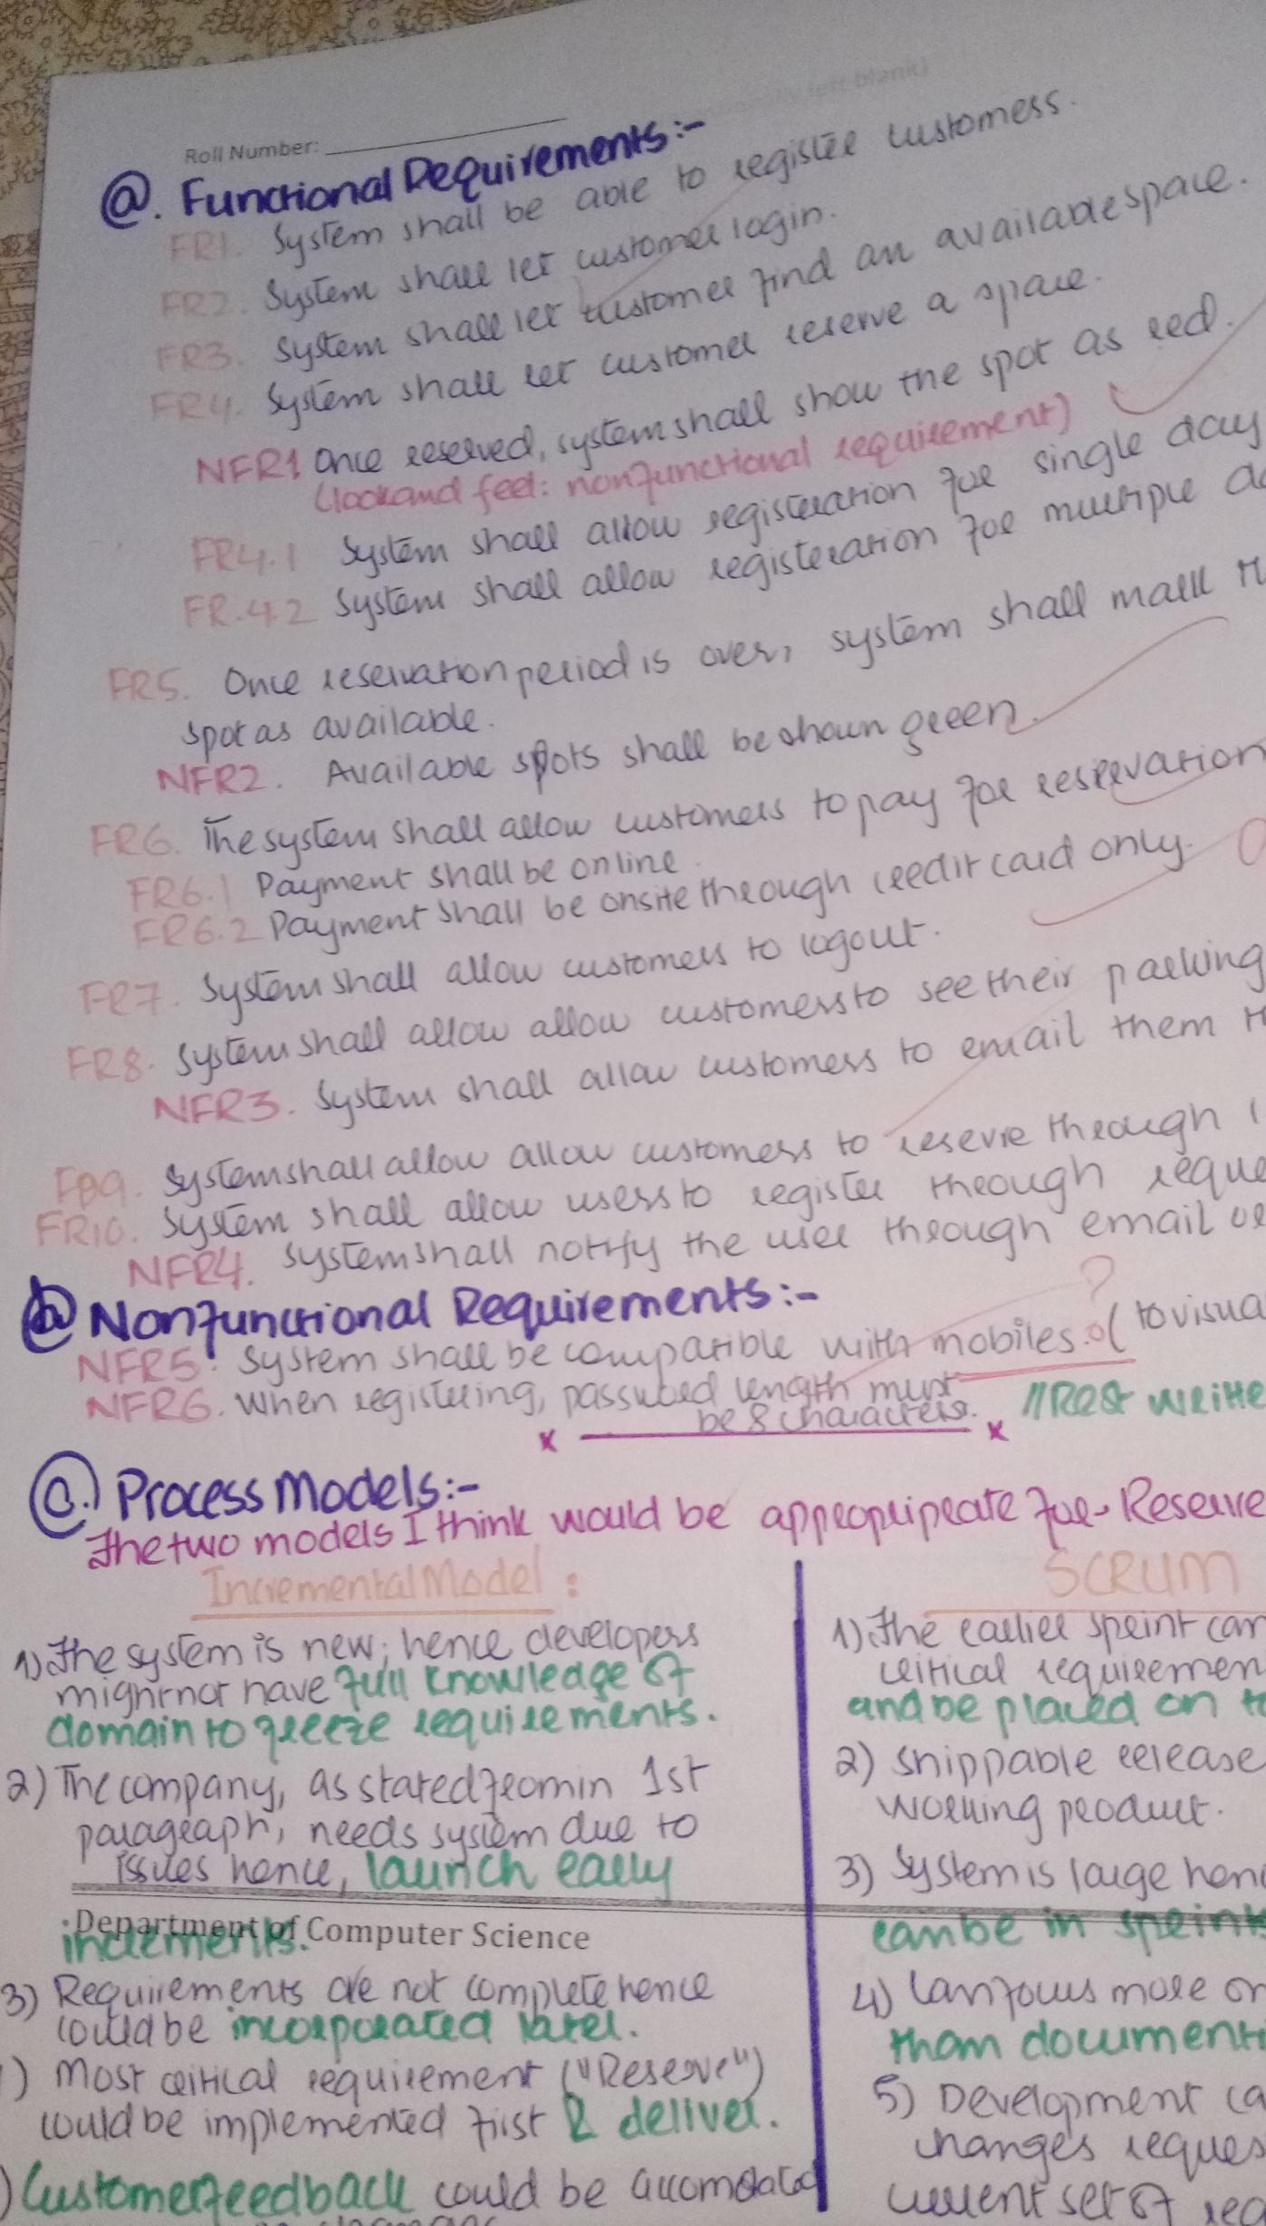

**Q2 8+2+5= 15Marks**

An in-car information system provides drivers with information on weather (EO), road traffic conditions (EO), and local information (EO), all on a single inquiry (EIQ). This system is linked to car radio so that information is delivered as a signal on a specific radio channel (EIF). The car is equipped with GPS receiver to discover its position and, based on that position (EI), the system accesses a couple of information services (EIFs). All information is saved in the local permanent storage (ILF)for future use and may be delivered in the driver’s specified language (EI).The EIs and EIQ are considered to be of low complexity, whereas the EOs and ILF are considered to be of average complexity. One of the EIFs is simple and the other two EIFs are complex in nature. The impact of 14 characteristics (or value adjustment factors) affecting the application is given by vector *Fi* = [4 2 0 4 3 4 5 3 5 5 4 3 5 5].**Weighting factors are as follows:**

| **Component** | Simple (Low complexity) | Average | Complex (High complexity) |
| --- | --- | --- | --- |
| External Inputs (EIs) | 3 | 4 | 6 |
| External Inquiries (EIQs) | 4 | 5 | 7 |
| Internal Logical Files (ILFs) | 3 | 4 | 6 |
| External Interface Files (EIFs) | 7 | 10 | 15 |
| External Outputs (EOs) | 5 | 7 | 10 |

**Function Points are calculated using the following expression:**

FP = count total * [0.65 + 0.01 * sum(Fi)]

**To do: Watch this video (**[**https://www.youtube.com/watch?v=AQNhh_8fw6w**](https://www.youtube.com/watch?v=AQNhh_8fw6w)**)**

1. Give a **Function Points (FP)** based estimate of size of the information system.
2. Using the FP based estimate of size, determine the **estimated lines of code** for the system. Assume 55 lines of code will be written per function point.
3. Based on the number of lines calculated in part b, calculate the **effort** required to complete the project where from the previous project history we know that it takes one person_month to complete 2000 lines of code (i.e. our productivity is 2 KLOC per person_month).

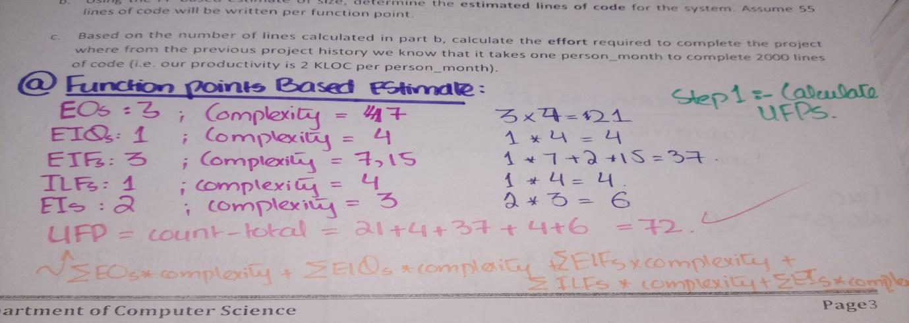

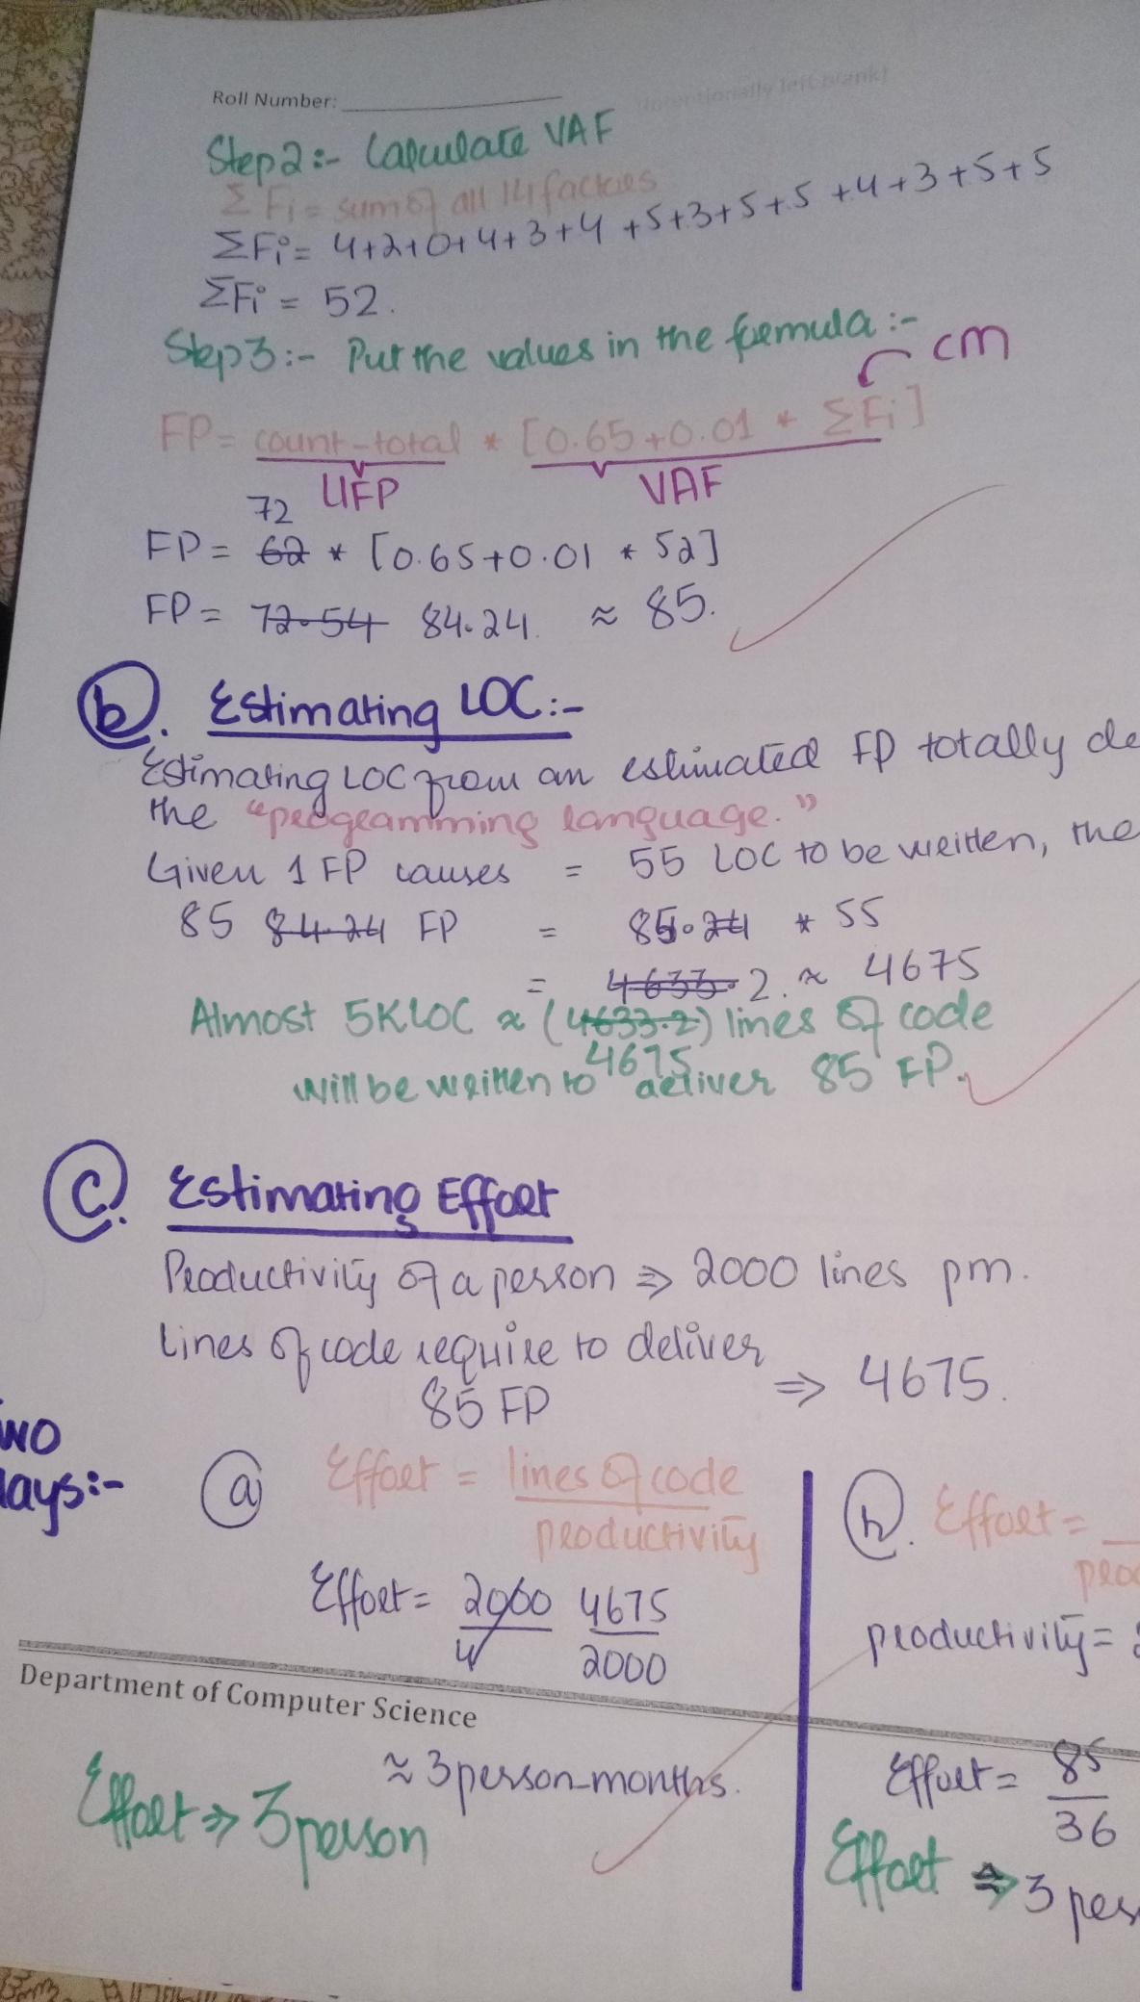

**Q3 10 Marks**

Develop a decision tree for the following situation.   
  
The base ticket price for Cloudliner Airlines is determined by the distance traveled and the day of the week a passenger is traveling. In addition, the airline adjusts it ticket prices based on a number of categories. If the seats remaining are greater than 50 percent of capacity and the number of days before the flight is less than 7, the price is deeply discounted with a special Web offer for the flight. If the seats remaining are greater than 50 percent and the flight date is from 7 to 21 days in the future, there is a medium price discount. If the seats remaining are greater than 50 percent and the number of days before travel are greater than 21, there is only a small discount.  
If the seats remaining are from 20 to 50 percent and the days before the flight are fewer than 7, the ticket has a medium discount. If the seats remaining are from 20 to 50 percent and the flight date is from 7 to 21 days in the future, there is a low discount for prices. If the seats remaining are from 20 to 50 percent and the number of days before travel are greater than 21, there is no discount.  
  
If the seats remaining are less than 20 percent and the number of days before the flight is less than 7, the ticket has the highest increase in price. If the seats remaining are less than 20 percent and the flight date is from 7 to 21 days in the future, there is a large increase in price. If the seats remainingess than 20 percent and number of days efore travel are greater than 21, there is a small increase in price. 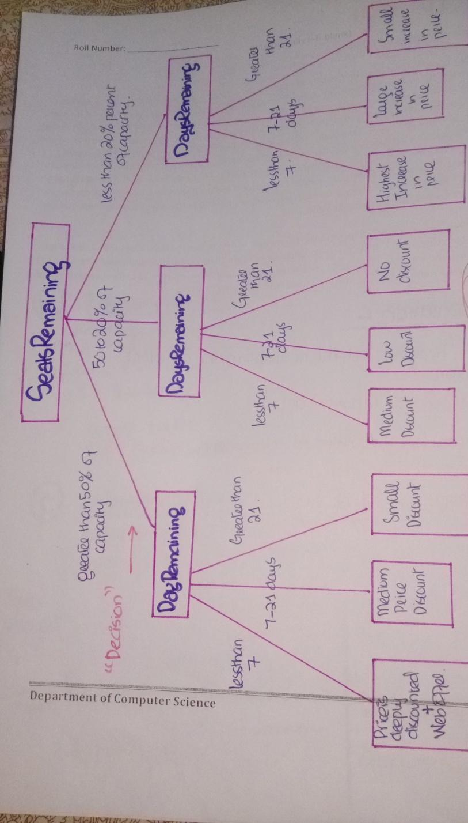

**Q4 3+1+3+3=10 Marks**

Consider the following code with line numbers mentioned:

| 1.public int binarySearch(int sortedArray[ ], int searchValue)  2.{  3. int bottom = 0, top = sortedArray.length - 1;  4. int middle, locationOfsearchValue;  5. boolean found = false;  6. int locationOfsearchValue = -1; /* the index of searchValue in the  sortedArray. -1 means not found */  7. while ( bottom <= top && !found){  8. middle = (top + bottom)/2;  9. if (searchValue == sortedArray[ middle ]) {  10. found = false;  11. locationOfsearchValue = middle;  12. }  13. else  14. if (searchValue < sortedArray[ middle ])  15. top = middle – 1;  16. }  17. else  18. bottom = middle + 1;  19. } // end while  20. return locationOfsearchValue;  21.} |
| --- |

**To do:**

1. Draw Control flow graph or Flow Chart of above code
2. Calculate cyclomatic complexity
3. Identify all paths to achieve 100% statement and branch coverage
4. Write test cases for each independent path

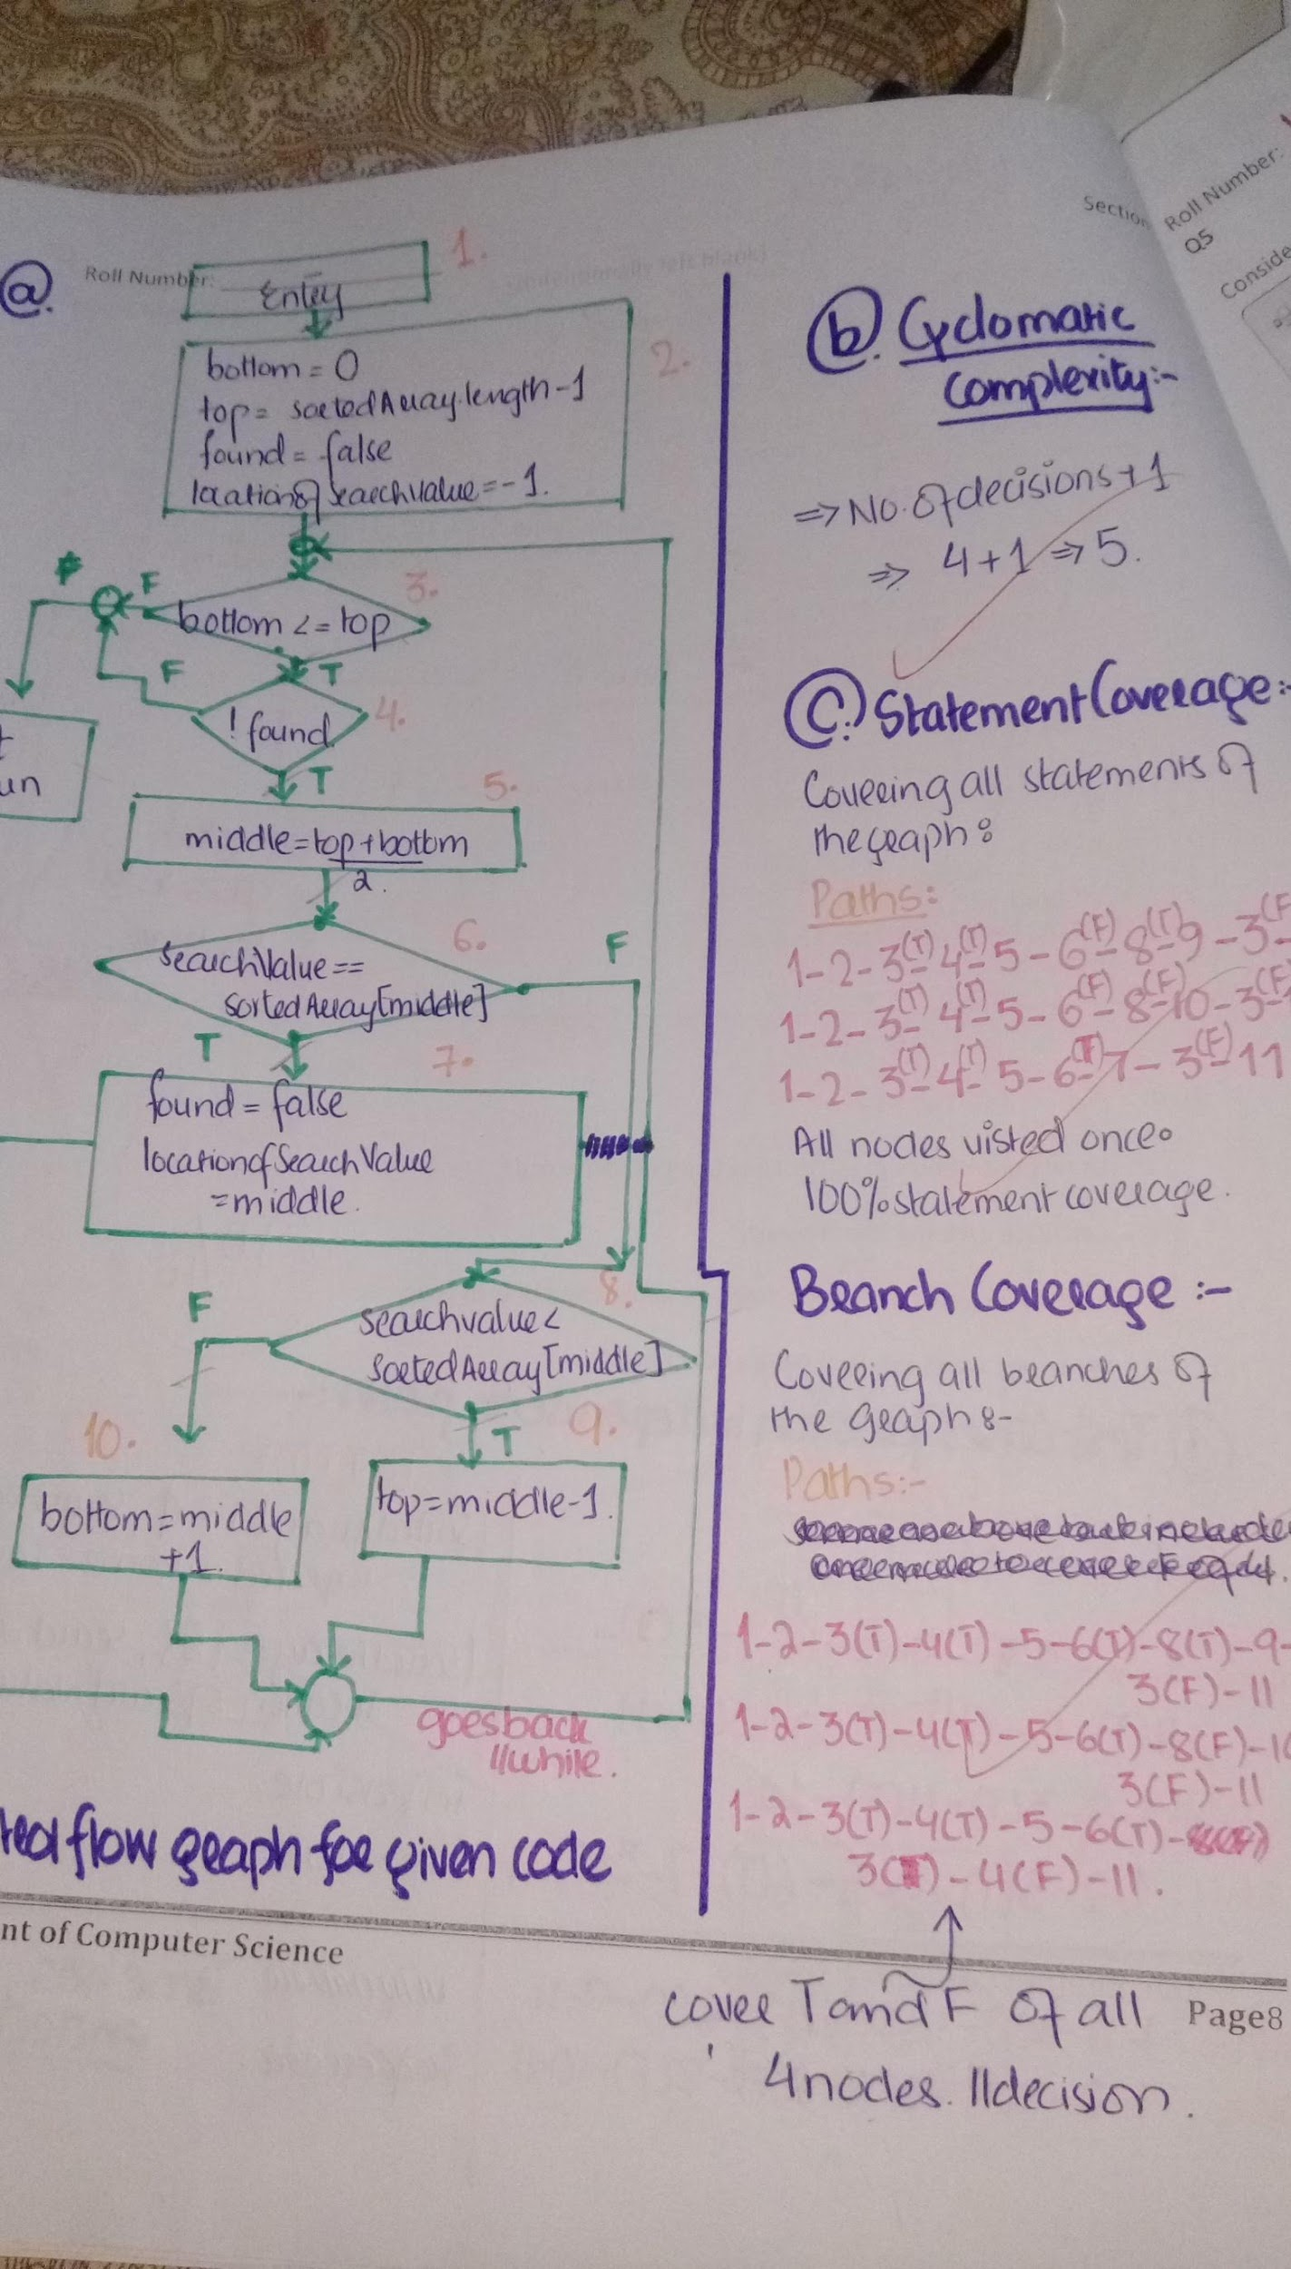**0**

**Q5 15 Marks**

Consider the following interface of an application that calculates weekly gross pay in Pakistani dollars (Ƥ):

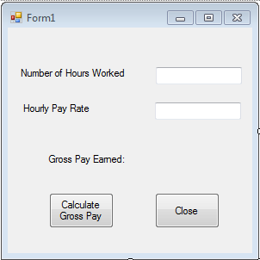

An employee cannot work for –ve numbers of hours and the maximum workload allowed is 60 hours a week. The minimum allowed hourly pay rate set by the Government is Ƥ 10. The company cannot afford the pay rate above Ƥ 30. The number of hours and the pay rate are rounded to the nearest integer value before their values are entered in the system. The employees are paid overtime if they work more than 40 hours a week. The pay rate remains the same but the hours above 40 are counted twice during gross pay calculations. For example if an employee has worked for 43 hours in a particular week and the pay rate for the employee is Ƥ 10. Then the gross pay of the employee will be calculated as follows:

Pay for first 40 hours: 40x10 = 400 (i.e. number of hours x pay rate)

Pay for the next 3 hours: (3x2)x10 = 60 (i.e. (number of hours x 2) x pay rate)

Gross Pay Earned: 400+60 = 460

**To do:**

1. Design equivalence classes for the two variables. Also design test cases based on the equivalence classes. How many test cases are required for the each variable?
2. Design the Boundary Value Analysis based test cases for the two variables.

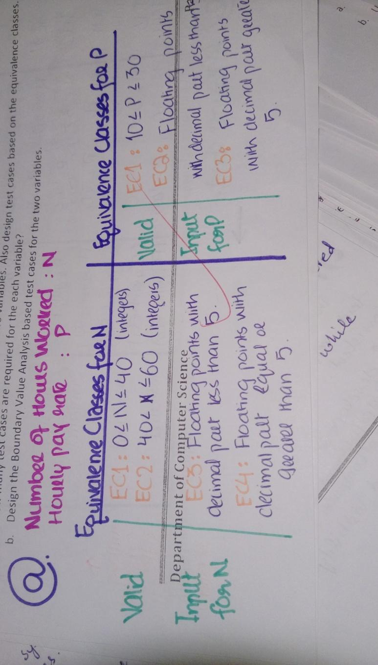

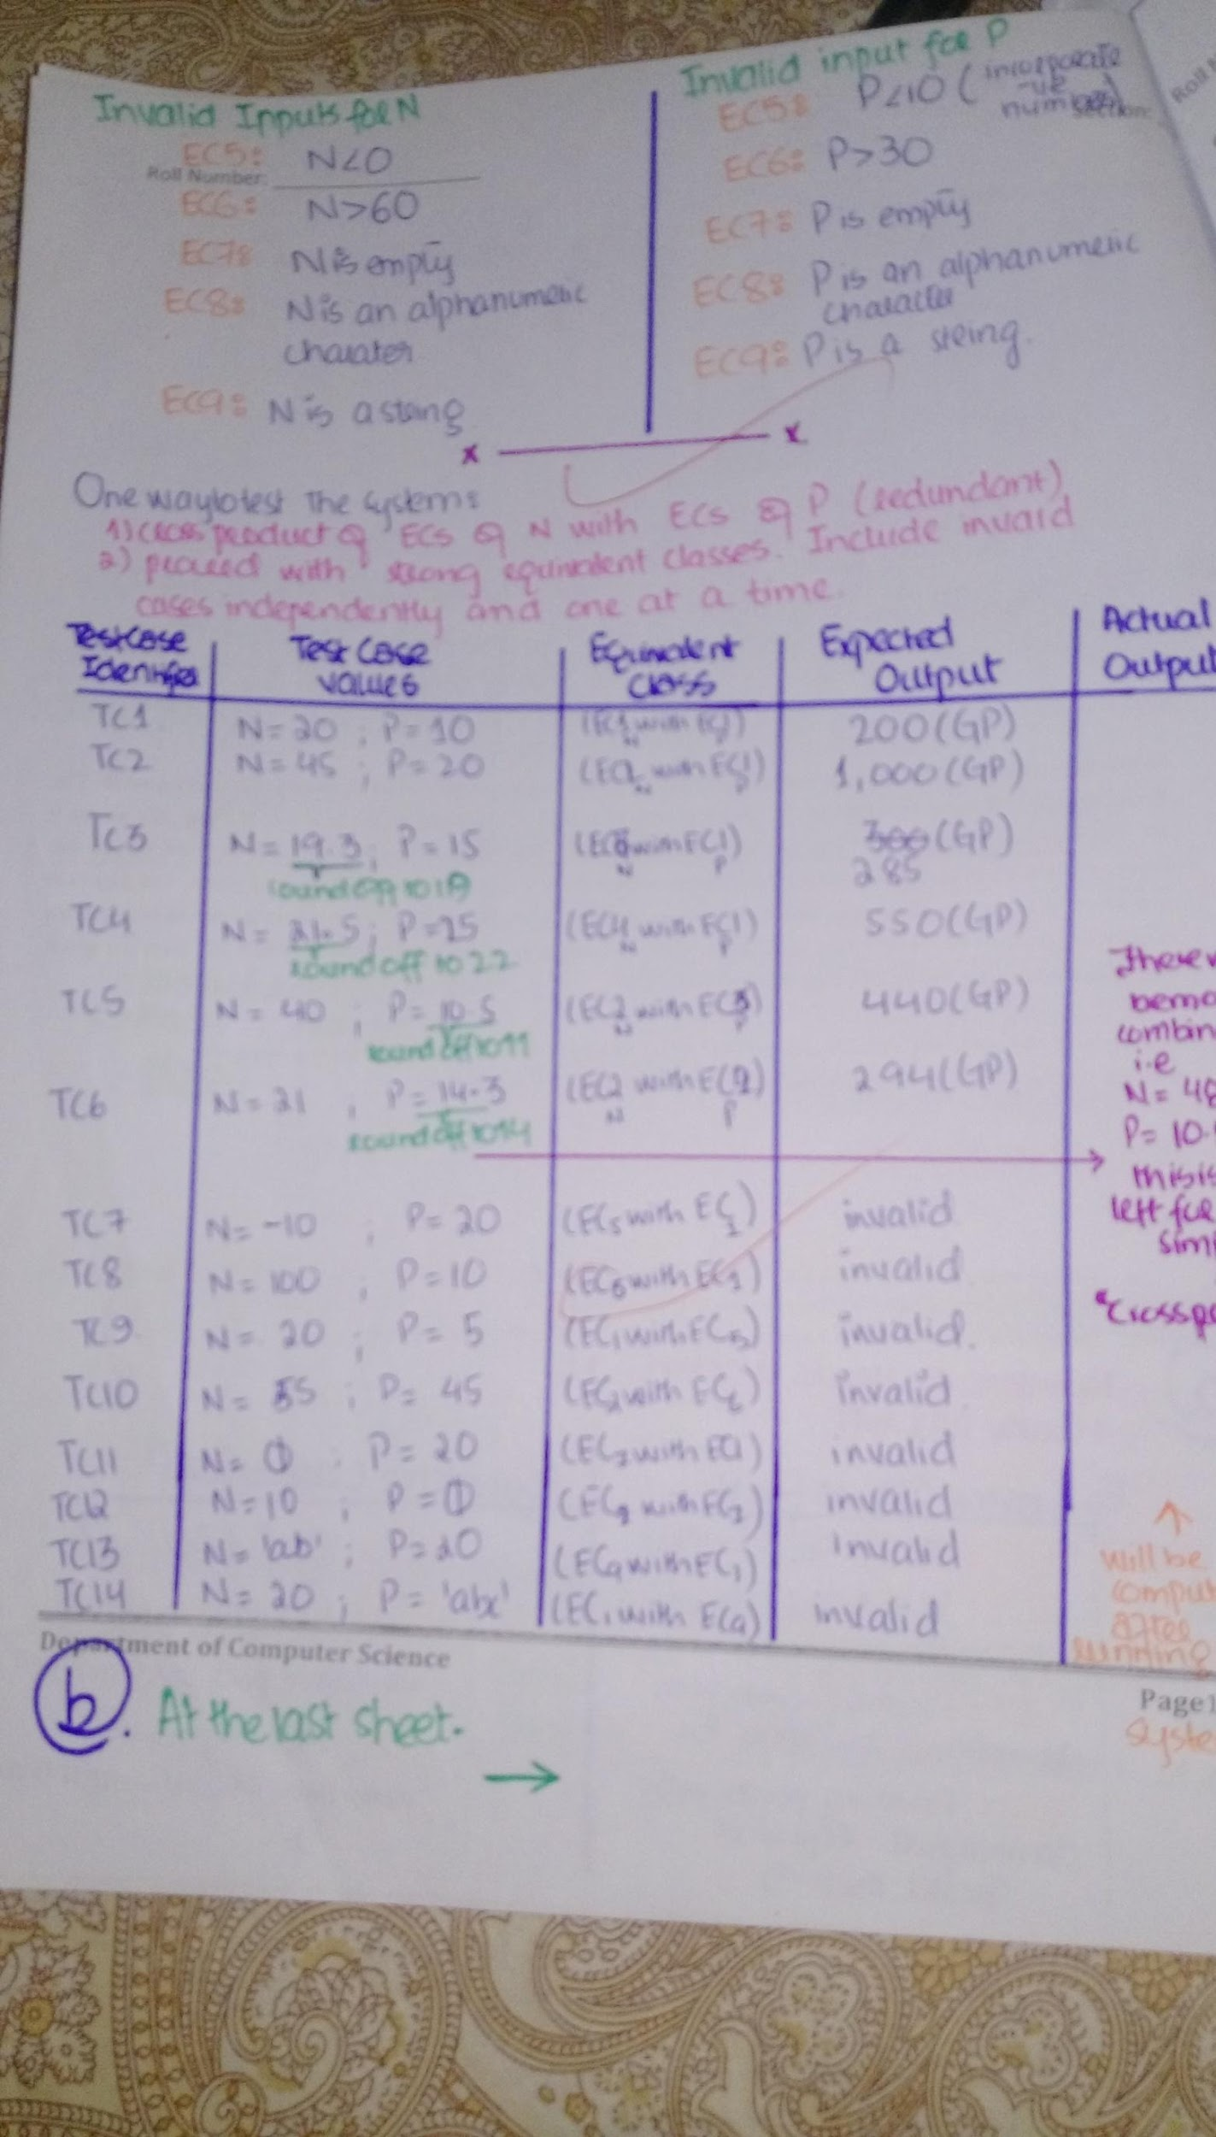

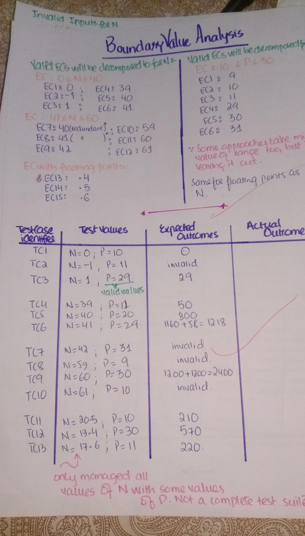

**Q 6 10 Marks**

Choose or write the appropriate answer

1. Which one is not the phase of Unified Process?
2. Inception
3. Elaboration
4. Communication
5. Construction
6. Backlog—a prioritized list of project requirements or features that provide business

value for the customer. It is created when we follow the process model named

1. Spiral Model
2. Extreme Programming
3. SCRUM
4. Feature Driven Development
5. Variant of the ----------------------------------is formal system development, where a mathematical model of a system specification is created.
6. Waterfall model
7. Prototyping
8. Incremental Software Development
9. Iterative Software Development
10. Following are the types of System-testing
    1. Recovery testing
    2. Security testing
    3. Deployment testing
    4. Performance Testing
11. Non-functional requirements define system properties and constraints e.g. reliability, response time and storage requirements. Constraints are I/O device capability, system representations, etc.
12. User Stories are similar to system requirements or use cases, but focus on the user benefits, instead on system features. preferred tool in agile methods.
13. Requirements are complete when they include descriptions of all facilities required.
14. Requirements are consistent when there are no conflicts or contradictions in the descriptions of the system facilities.
15. Programmer’s productivity= LOC per unit of time
16. Cyclomatic complexity (CC) remains same for a linear sequence of statements regardless of the sequence length.